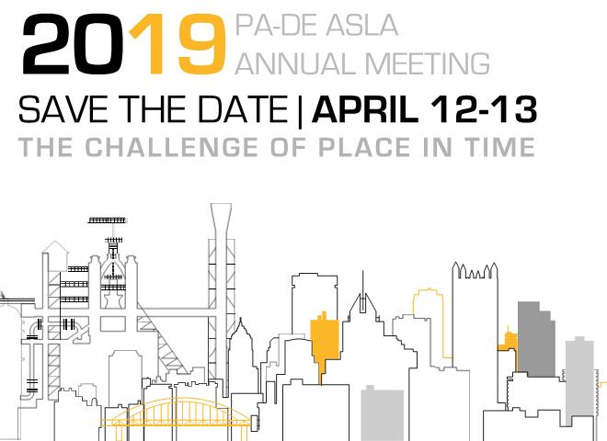

August 1, 2018
OPEN CALL FOR PRESENTATIONS

The Pennsylvania Delaware (PA-DE) Chapter of the American Society of Landscape Architects is soliciting an Open Call for Presentations for their 2019 PA-DE Annual Meeting April 12 & 13 at the DoubleTree by Hilton Hotel in Cranberry Township, Western Pennsylvania. The theme for this years meeting is The Challenge of Place in Time.

Presenters with knowledge and experience found to be beneficial to peer professionals are highly desired. Fitting in the framework of the theme of the meeting, The Challenge of Place in Time, are topics that examine change in our environment that mark the passage of time and new beginnings for our region of the country. Subjects may concern a broad range and scale of topics, and may be derived from a past project or recent research – essentially anything that impresses passion in ones profession, and relates to the field of landscape architecture.

The two-day meeting will offer several one-hour educational sessions. Selected presenters will receive complimentary luncheon and admission to other presenter sessions on the day of the presentation.
For further information about the submission process please see the top section of the following page. Only electronic submissions will be considered, and subsequent correspondence will be in the like.

The PA-DE Chapter Annual Meeting Planning Committee hopes that you will consider presenting, and share this information with anyone who may also be interested in presenting, at the 2019 PA-DE ASLA Annual Meeting The Challenge of Place in Time.

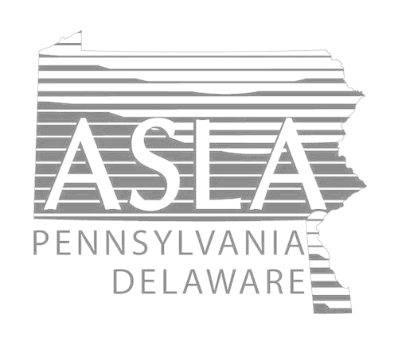

2019 PA-DE ASLA ANNUAL MEETING
The Challenge of Place in Time

OPEN CALL FOR PRESENTATIONS

Submissions
Please submit the information listed below in a Word document to kkanspedos@bohlereng.com:
• Presentation Title
• Speaker(s) Biographie(s)
• Learning Objectives
• Presentation Abstract (maximum 750 Characters or 75 words)
• Presentation Summary (300 words or less)

Submission Evaluation and Selection
The ASLA PA-DE Annual Meeting Speakers Committee will review and evaluate submissions using the
following criteria:
• Clearly articulated, well developed submission with knowledgeable presenters
• Relevance to the profession of landscape architecture
• Clearly stated and achievable learning objectives
• Timeliness of the topic
• Subject matter appeal
• Speaker qualifications and past evaluation results

Schedule
Monday, August 1, 2018: Open Call for Presentations
Monday, October 1, 2018: Close Call for Presentations
Friday, November 2, 2018: Email Confirmation sent to Proposers
Friday, April 12 & Saturday. April 13, 2019: Educational Sessions at Annual Meeting
Policies Governing Accepted Proposals
- The lead presenter will serve as the prime point of contact for ASLA staff and is responsible for coordinating with all other presenters involved in a session. All speakers listed on the proposal must be aware that they are being considered, eligible and willing to participate as a speaker if the program is selected.
- All presenters in a session must be included in the original submittal. Speakers may not be changed and no additional speakers may be added without ASLA approval once a proposal is accepted.
- Submissions promoting specific product brands or companies will not be considered.
- All presentations must have a visual component that may be projected for all session attendees to view, such as a PowerPoint slideshow (photos, graphs, charts, video, etc.)
- Selected presenters may be requested to submit additional information if necessary for continuing education program approval.
- If you will have handouts, please notify ASLA of your needs.
- ASLA reserves the right to edit any submitted materials for promotional purposes.
- ASLA reserves the right to cancel a session at any time.
- ASLA reserves the right to combine similar sessions, change titles and descriptions, or add/change speakers as necessary. You will be notified if there are any changes and given the opportunity to modify your program accordingly.
- Sessions may be scheduled at any time on Friday April 12, 2019 or Saturday April 13, 2019. Speakers must be available to present on either day.
- Speakers selected to present at the meeting will receive complimentary registration for the day of their presentation. ASLA will not reimburse travel expenses or provide fees or honoraria for education session speakers.

2019 PA-DE ASLA ANNUAL MEETING
The Challenge of Place in Time

OPEN CALL FOR PRESENTATIONS
submission template

Please submit the information listed below as a Word document
by Monday October 1, 2018 to: kkanspedos@bohlereng.com

Presentation Title (exactly as it will be displayed in print):

Speaker(s) Name(s) (exactly as it will be displayed in print):

Speaker(s) Bio(s) (approx.150 words or less/eh.; read aloud by a session moderator prior to the presentation):

Learning Objectives (please provide minimum of 4 for use in obtaining continuing education credit):
1.)
2.)
3.)
4.)

Presentation Abstract (50 - 75 words; published in the meeting brochure):

Presentation Summary (300 words; published in the meeting booklet):

Speaker suggested educational credit ( [X] box, please): [ ] LACES [ ] AICP [ ] LEED (specialty ___ )

